Read Me:
This is a word document to enable inputting of quiz questions for PA Med LMS. There are 2 scenarios with 5 questions each. The 5 questions for each scenario align in topic throughout the quiz and get progressively harder. For example, questions 1 and 6 are easy Yes/No and questions 5 and 10 involve in-depth consideration of the Details of Delivery tool. The explanation for why an answer is right or wrong is referred to as “Rationale” and included indented under each answer choice.
Scenario 1 Description: As Chief Medical Officer for a chain of local ambulatory surgery centers (ASCs), you participate in regular strategy meetings with other leaders and members of the board that oversee your organization. Your Chief Financial Officer recently read a report on the financial health of the state’s ASCs and has asked an analyst to put together a summary for you and the other leaders in your organization.

Select the correct answer from the choices provided for each of the questions:
Question 1: Identify biases, recognize limitations, and evaluate data sources.
In advance of your next strategy meeting, this summary is shared with you by email. The summary contains a short description of what the data says and a few visualizations. At the bottom, there is an url hyperlink (link) to the page on the internet where the report can be found and read in full. When you click on that link, you find that in addition to the report you can access information about the organization and the methods used in developing this report.
Has this summary been communicated to you in a way that is factual, transferrable, ethical, and transparent?
- Yes
  - Rationale: Correct! The url hyperlink at the bottom of the summary enables readers to further investigate the source. Further information about the report, the methods, and the organization producing the report are all key pieces to identifying trustworthy data. It’s important to remember that another human has touched this data before it was shown to you, so you still need to understand any effects that may have had. We’ll focus on interpreting the data in the summary in the next question.
- No
  - Rationale: Incorrect. The url hyperlink at the bottom of the summary enables readers to further investigate the source. By examining the source information, the reader can determine if the summary is factual, based on the report. Allowing the reader to critically evaluate the source of the information makes the data transferable and is considered an ethical and transparent behavior.
Question 2: Interpret by evaluating data source and processing.
The summary contains this data visualization below.
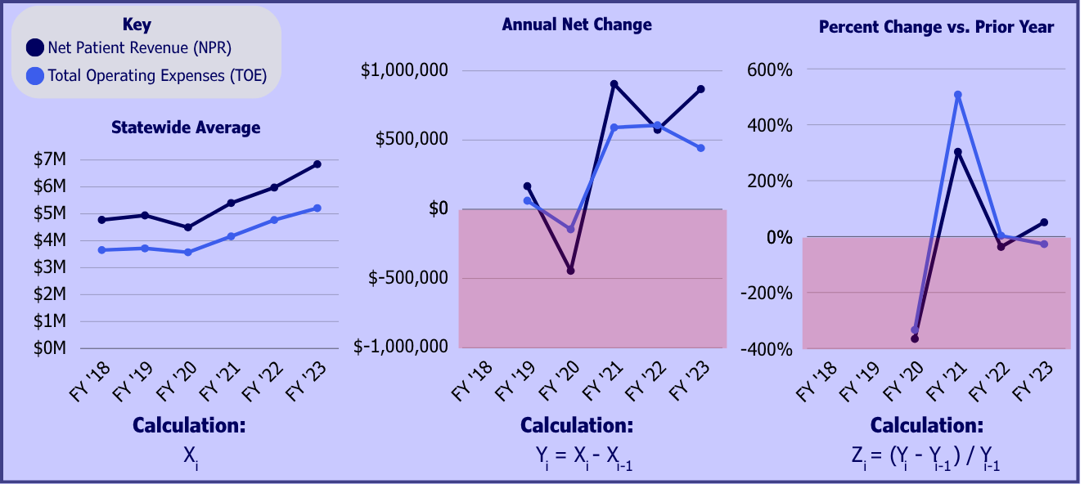
You’ll recall from the learning module that all three of these graphs are derived from the same data. They look different because of the different mathematical operations listed beneath each graph.
By looking at the first graph titled “Statewide Average”, you determine that ASCs are generally profitable in Pennsylvania, earning more in NPR than spending in TOE every year visualized. From the second graph, you determine that fiscal year 2020 was an exception, because NPR is lower than TOE.
Select the answer choice that is most appropriate
- Both your first and second determinations are true.
  - Rationale: Incorrect. The first determination is true, but the second is false. It is false because graph 2 isn’t displaying the total NPR or TOE, it is displaying the change in those. In FY ’20, ASCs made more in NPR than spent in TOE, this is shown in the first graph. The second graph is annual net change and subtracts FY ’19 from FY ’20. This graph shows ASC’s made less in NPR for FY ’20 and spent less in TOE compared to FY ’19.
- Your first determination is true, but your second determination is false.
  - Rationale: Correct! The first determination is true, and the second is false. In FY ’20, ASCs made more in NPR than spent in TOE, this is shown in the first graph. The second graph is annual net change and subtracts FY ’19 from FY ’20. This graph shows ASC’s made less in NPR for FY ’20 and spent less in TOE compared to FY ’19.
- The first determination is false, but the second determination is true.
  - Rationale: Incorrect. The first determination is true, and the second is false. NPR is above TOE in every year of the first graph, making the first determination true. The second graph is annual net change and subtracts FY ’19 from FY ’20. This graph shows ASC’s made less in NPR for FY ’20 and spent less in TOE compared to FY ’19.
- Both determinations are false.
  - Rationale: Incorrect. The second determination is false, however the first determination is true. NPR is above TOE in every year of the first graph, making the first determination true. The second graph is annual net change and subtracts FY ’19 from FY ’20. This graph shows ASC’s made less in NPR for FY ’20 and spent less in TOE compared to FY ’19.
Question 3: Interpret data by identifying bias.
Imagine the CFO wants to deliver an overall message in this summary that was generally more positive in tone and asks the analyst to remove two of the graphs and only show one. Which would be the best graph for the analyst to choose?
- Statewide Average
  - Rationale: Correct! This is the only graph that doesn’t contain negative numbers, and this graph displays the profitability of ASCs over time clearly.
- Annual Net Change
  - Rationale: Incorrect. This graph contains a large red area indicating negative numbers which can hurt the positive tone of the summary. It does show that growth in NPR has outpaced growth in TOE for 2 of the last 3 years. However, this is not immediately apparent to the reader, unlike the large area indicating negative numbers. The Statewide Average graph presents the profitability of ASCs without showing negative numbers.
- Percent Change vs. Prior Year
  - Rationale: Incorrect. This graph contains a large red area indicating negative numbers which can hurt the positive tone of the summary. Additionally, this graph has the highest level of mathematical processing to the data which requires extra focus to fully understand. The Statewide Average graph presents the profitability of ASCs without showing negative numbers.
Question 4: Apply the Details of Delivery tool.
The rising cost of providing care is a common topic of conversation in team meetings with your surgeons and other staff. You plan to bring this summary to the next meeting to discuss the rising cost of care statewide in ASCs and to make the point that diligence and quality practice are key to keeping costs down. To make sure this message is communicated to the best of its ability, you pull out your Details of Delivery tool.
The first three columns have been pre-filled. Which of the following contains the correct information in the correct order for the remaining cells in the Details of Delivery tool?
Details of Delivery
Data  Source | Unit of Measurement | Target Audience | Desired Outcome | Setting | Discussion Type | Supporting Arguments
CFO Summary | Dollars | Staff/  Team
- Your team stays focused on quality, low-cost care; Team Meeting; Sharing Information; Statewide Average graph showing the rising total operating expenses.
  - Rationale: Correct! You’re sharing information that you learned with your team in a meeting so they may stay focused on quality, low-cost care. The Statewide Average graph is the best graph to support this message because it shows the total dollar figure for providing care has risen over time.
- Your team stays focused on quality, low-cost care; Board Meeting; Sharing Information; Annual Net Change graph showing the change in total operating expenses.
  - Rationale: Incorrect. The desired outcome and discussion type are correct. However, the setting is a team meeting, not a board meeting. Additionally, the Statewide Average graph better supports the message than the Annual Net Change graph because it shows the total dollar figure for providing care has risen over time in a clear visualization.
- Your costs remain low; Team Meeting; Sharing Information; Percent Change vs. Prior Year graph.
  - Rationale: Incorrect. The desired outcome is better stated as “Your team stays focused on quality, low-cost care” as in the other answer choices. Additionally, the Percent Change vs. Prior Year graph is the least easy to understand. The Statewide Average graph is the best choice because it shows the total dollar figure for providing care has risen over time in a clear visualization.

Question 5: Apply the Details of Delivery tool.
Now consider how your answers to the previous question would change if you were a public health official and were sharing this summary of your organization’s report in a public meeting, instead of an internal team meeting. These meetings occur on a regular cycle when your organization puts out information like this and you take the time to collect comments and questions from the public.
The first three columns have been pre-filled. Which of the following contains the correct information in the correct order for the remaining cells in the Details of Delivery tool?
Details of Delivery
Data  Source | Unit of Measurement | Target Audience | Desired Outcome | Setting | Discussion Type | Supporting Arguments
Published Report | Dollars | General Public

- Public Meeting; Education and the opportunity for the public to ask questions; Question and Answer session; Statewide Average graph.
  - Rationale: Incorrect. The first two answers have been switched and the best supporting argument is the summary visualizations and description. Using the full summary visualizations is the right choice instead of just the Statewide Average graph because different stakeholders may favor different visualizations.
- Education and the opportunity for the public to ask questions; Public Meeting; Question and Answer session; Summary visualizations and description.
  - Rationale: Correct! You’re conducting a public question and answer session which helps educated the public and invite questions. Using the full summary visualizations is the right choice because different stakeholders may favor different visualizations.
- Question and Answer session; Public Meeting; Annual Net Change graph; Education and the opportunity for the public to ask questions.
  - Rationale: Incorrect. The answer choices are not in the correct order. Additionally, using the full summary visualizations is the right choice instead of just the Annual Net Change graph because different stakeholders may favor different visualizations.
- Education and the opportunity for the public to ask questions; Public Meeting; Question and Answer session; Percent Change vs. Prior Year graph.
  - Rationale: Incorrect. The best supporting argument is the summary visualizations and description. Additionally, using the full summary visualizations is the right choice instead of just the Percent Change vs. Prior Year graph because different stakeholders may favor different visualizations.
Scenario 2 Description: Your practice recently added online consults to the number of services offered to existing patients. This is the first time your practice has attempted to incorporate online consults and early data shows your existing patients have scheduled online consults at a rate higher than the conservative goal. You're already at 56% of the goal and it's only been 4 months! You would like to communicate the success of this program to your partners at the next internal directors meeting and you would like to propose the practice budget for expected revenue from online consults increases for the following year.

Select the correct answer from the choices provided for each of the questions:
Question 6: Identify biases, recognize limitations, and evaluate data sources.
The data visualization on your dashboard displaying 56% achievement pulls data in a live stream from the patient scheduling assistant built into your practice EHR.
Is this data source considered trustworthy?
- Yes
  - Rationale: Correct! The practice EHR collects, stores, and processes the data from the scheduling assistant all internally. The data source is local and relevant to your topic and, importantly, you understand how it was collected and can communicate that to others.
- No
  - Rationale: Incorrect. The practice EHR collects, stores, and processes the data from the scheduling assistant all internally. The data source is local and relevant to your topic and, importantly, you understand how it was collected and can communicate that to others. These strengths make this data source trustworthy.

Question 7: Interpret by evaluating data source and processing.
Does the below visualization show that more individuals scheduled online consults in the first two weeks of March than in the first two weeks of February?
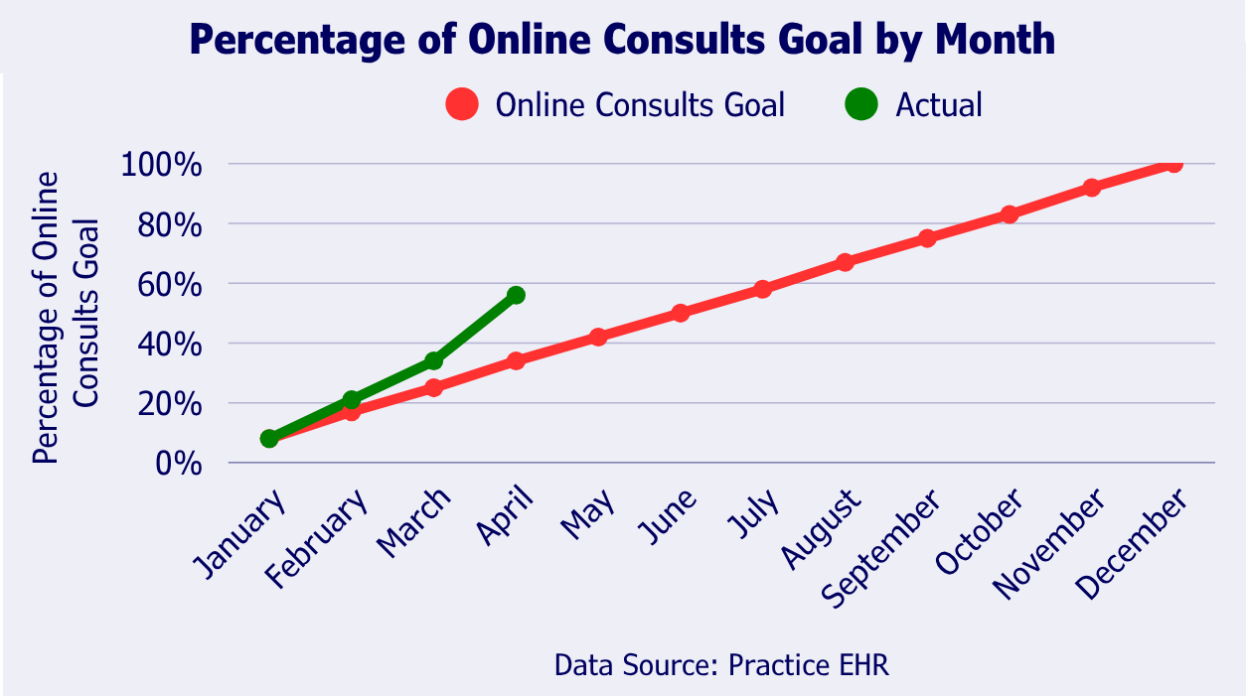
- True
  - Rationale: Incorrect. The data is aggregated, or counted, at a monthly level. You can not see the data by week in this visualization. Amending the visualization to show weekly appointments instead of monthly is referred to as “increasing the granularity of the data”. A weekly visualization would have more data points than a monthly which can be harder to read but is better for closer study.
- False
  - Rationale: Correct! You can not see the data by week in this visualization. Amending the visualization to show weekly appointments instead of monthly is referred to as “increasing the granularity of the data”. A weekly visualization would have more data points than a monthly which can be harder to read but is better for closer study.

Question 8: Interpret data by identifying bias.
The following visualization shows what assumption, which may or may not be true?
- Patients like online consults better than in-person consults.
  - Rationale: Incorrect. This visualization doesn’t display anything about patient opinions.
- The red line visualizing the goal assumes a consistent rate of patient uptake for online consults, rather than another pattern of behavior such as seasonal increases or decreases.
  - Rationale: Correct! The red line increases by 8.33% with each new month, showing a consistent growth in online consults until the goal is met. This type of forecasting is easy to understand and to calculate. However, it is also common in health care to forecast data like this with seasonal variation.
- The green line visualizing the percentage of the goal will continue to go up.
  - Incorrect. The green line shows the number of current appointments. It doesn’t show anything about the likelihood of future appointments.

Question 9: Apply the Details of Delivery tool.
Your practice has several reimbursement contract meetings scheduled in the next few weeks and they want you to speak about the success of the online consults and how its saving money for payers and you’re planning to expand your online services.
Most of the tool has been filled in for you. Which of the following contains the correct information in the correct order for the remaining cells in the Details of Delivery tool?
Details of Delivery
Data  Source | Unit of Measurement | Target Audience | Desired Outcome | Setting | Discussion Type | Supporting Arguments
 |  | Representatives from Payers | Demonstrating a commitment to lower costs | Contract meeting | Presentation of Results and Successes | Percentage of Online Consults Goal by Month graph

- Practice EHR; Number of consults in a four-month period
  - Rationale: Incorrect. The Percentage of Online Consults Goal by Month graph shows percentages not the raw number.
- Academic Journal; Percentage of actual online consults compared to the goal
  - Rationale: Incorrect. The data source is the practice EHR which is cited as the source under the graph in the previous two questions.
- Practice EHR; Percentage of actual online consults compared to the goal
  - Rationale: Correct. Data from the practice EHR was used to calculate percentages and compare the actual number to the goal.
- None of the above
  - Rationale: Incorrect. The data source is the practice EHR which is cited as the source under the graph in the previous two questions. Additionally, the Percentage of Online Consults Goal by Month graph shows percentages of actual consults compared to the goal.

Question 10: Apply the Details of Delivery tool.
One of the partners at your practice teaches part-time at the neighboring medical school and suggested you come in to educate their students on the success of the program. How would the Details of Delivery tool change if you were going to present the success of this program to a room of medical students at the local medical school?
Most of the columns in the tool have been filled in for you. Which of the following contains the correct information in the correct order for the remaining cells in the Details of Delivery tool?
Details of Delivery
Data  Source | Unit of Measurement | Target Audience | Desired Outcome | Setting | Discussion Type | Supporting Arguments
Practice EHR | Percentage of actual online consults compared to the goal |  |  | Medical School Classroom |  | Percentage of Online Consults Goal by Month graph
- Educational Session; Student Learning; Medical Students
  - Rationale: Incorrect. These are the correct answers, but they are out of order. The medical students are the target audience and you, the educator, are looking for the students to learn in an educational session.
- Representatives from Payers; Demonstrating a commitment to lower costs; Presentation of Results and Successes
  - Rationale: Incorrect. These are the correct answers for the previous scenario. When presenting the same information to different audiences it can be easy to confuse or swap information from one with the other. It’s important to check that the Details of Delivery Tool is fully up to date each time you approach a new audience.
- Medical Students; Student Learning; Educational Session
  - Rationale: Correct. You will be speaking as an educator to help medical students learn about other mediums of care delivery in an educational session.
- None of the above
  - Rationale: Incorrect. You will be speaking as an educator to help medical students learn about other mediums of care delivery in an educational session.

